SCLA December Board Meeting – Dec 6th, 2023 - Zoom
Attendance: Kelly Jones, Amanda Myers, Tomeka Jackson, Jonathan Newton, Melanie Huggins, Angela Craig, Mckenzie Lemhouse, Sarah Schroeder, Matthew Smith, Mary Kate Quillivan, Tiffany Hayes, Lisa Gieskes, Doris Johnson-Felder, Sonaite Debebe- Kumssa, Lindsey Taunton, Kristin Hare, Tucker Taylor, Allison Read, Donald Wood, Jennifer Jean, Randy Dantrell Heath, Cathi Mack, Virginia Cononie

Adopt Agenda
Sarah Schroeder – motion
Tucker Taylor- second
All in Favor

Approve Minutes from October Board Meeting
Jonathan Newton- motion
Amanda Myers- second
All in Favor

Approve Minutes from October Membership Meeting- Melanie
Sarah Schroeder- motion
Tucky Taylor- second
All in Favor

Executive Committee Reports

President’s Report—Melanie Huggins
- Grateful to Executive Committee and being in the role of President.
- Building relationships with other library membership organizations such as SCASL, APLA, and PASCAL.
- SCLA offers to help SCASL fill in gap for continuing education opportunities that were disbanded because of the relationship with the Department of Education.
- On October 5 or 6th received another letter from the Freedom Caucus. A response was drafted and shared with the board with some input. In the end, I decided not to send a response letter due to limited responses.

Election Results- Kelly Jones
- Incoming new 2024 executive committee officers – Angela Craig as President, Janice Steveson as Treasurer, Valerie Byrd for secretary, Kelly Jones as first Vice President, Sarah Schroeder – as ALA councilor, Tiffany Hayes as Second Vice President, New chairs- McKenzie South Carolina Journal, Two chairs of section – Dr Cromartie for African American Concerns, and Stacy Winchester for College and University section.
- All four bylaws and amendments passed.

Executive Secretary’s Report—Donald Wood
- Billed APLA for 1,500 sponsorships.
- All bills paid just need to reconcile those paid with credit card for the final financial statement. Once invoices are posted we will know more.
Membership Report— Kelly Jones
- 347 active members
- Fix issued with email list to SCLA membership all active members are getting emails but if anyone isn't contact me.
- The new institutional membership model is approved and will be implemented in 2024 and will go live within the first few months.
- The membership committee discussed ideas for engaging the influx of new members in the coming new year.

Treasurer’s Report—Sarah Schroder
- Settling funds from conference.
- The current balance sheet is 80,833.53 and counting on the fact that we are still paying our vendors.
- We made money from the conference, and everything was budgeted well so we did not spend all the allotted funds.

ALA Councilor Report—Sarah Schroder
- New ALA appointed interim executive director Leslie Burger. [ last name spelling]
- A committee was established to discuss updated standards for accreditation of MLIS programs. (voted on standards and it passed)
- Voted on updated executive board members election rules and it passed.
- Executive deputy director search using executive search firm Isaacs and Miller hoping for new director in time for ALA conference in 2024.
- ALA hosting Chapter Advocacy Academy this weekend in Chicago. Every state sends two representatives: One from the school library association and the other from the chapter. Also, Jamie Gregory is going from SCASL.

Conference Recap—Jimmie Epling ( Donlad for Jimmie)
220 attendees, 20 booths and exhibitors,
2024 conference dates are set which will be in Columbia, South Carolina.

Items of Business
SCLA Journal Social Media Account – Sonaite Debebe-Kumssa/ Mckenzie Lemhouse,
- The SCLA Journal is interested in creating a separate social media account apart from the established SCLA account. The goal is to communicate with authors, get journal submissions, and spread the word more.
- McKenzie- The social media account would be for direct communication with interested authors, peer reviewers, annual events, and soliciting conference proceedings.

Motion: SCLA asked to consider if SCLA Journal Team can create its own social media account.
- First : Tucker Taylor
- Second Sarah Schroeder
- All in Favor
Motion to table the action for SCLA journal Team to have a sperate social media account.
- Motion- Allison Read
- Second- Kelly Jones
- All in Favor

Amendment to Motion
- Friendly amendment to the previous motion to table the SCLA Journal . We ask that a member of the journal team have a seat on the Marketing and Communications Committee to have adequate promotion and marketing.
- Motion- Kelly Jones
- Second-Tucky Taylor
- All in favor
Marketing Committee Social Media Policy Proposal- Sonaite Debebe- Kumssa
[screenshot of social media policy]
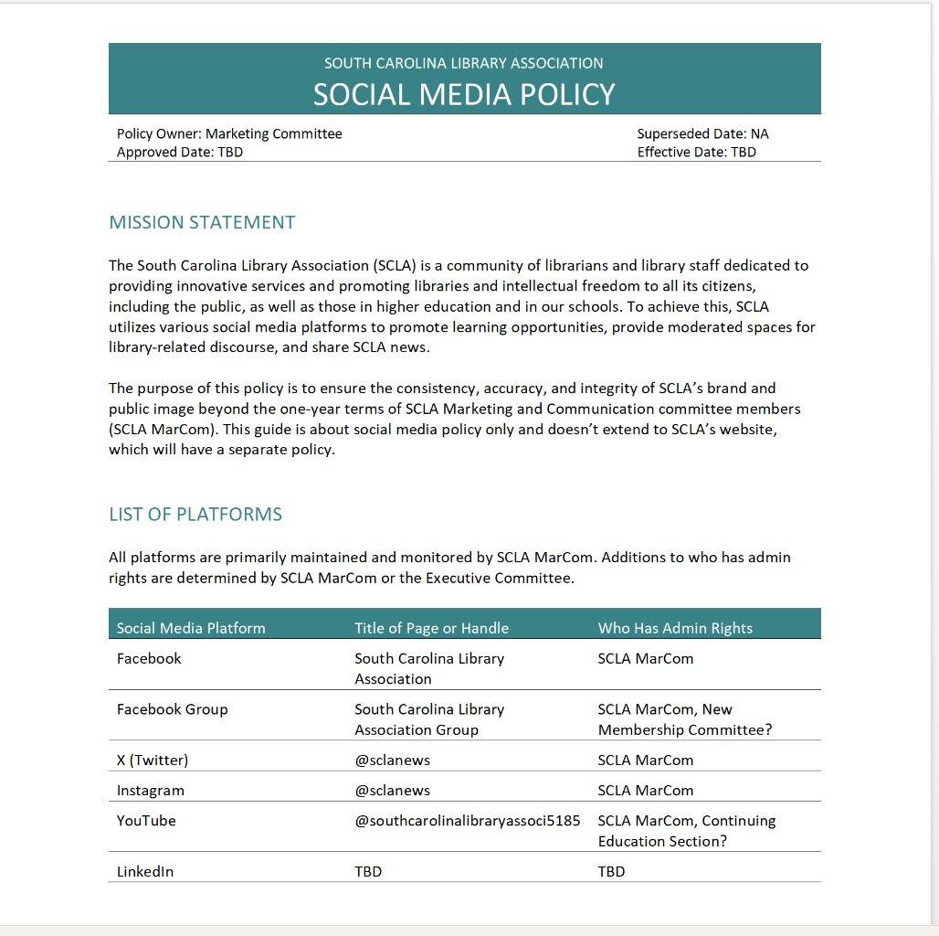

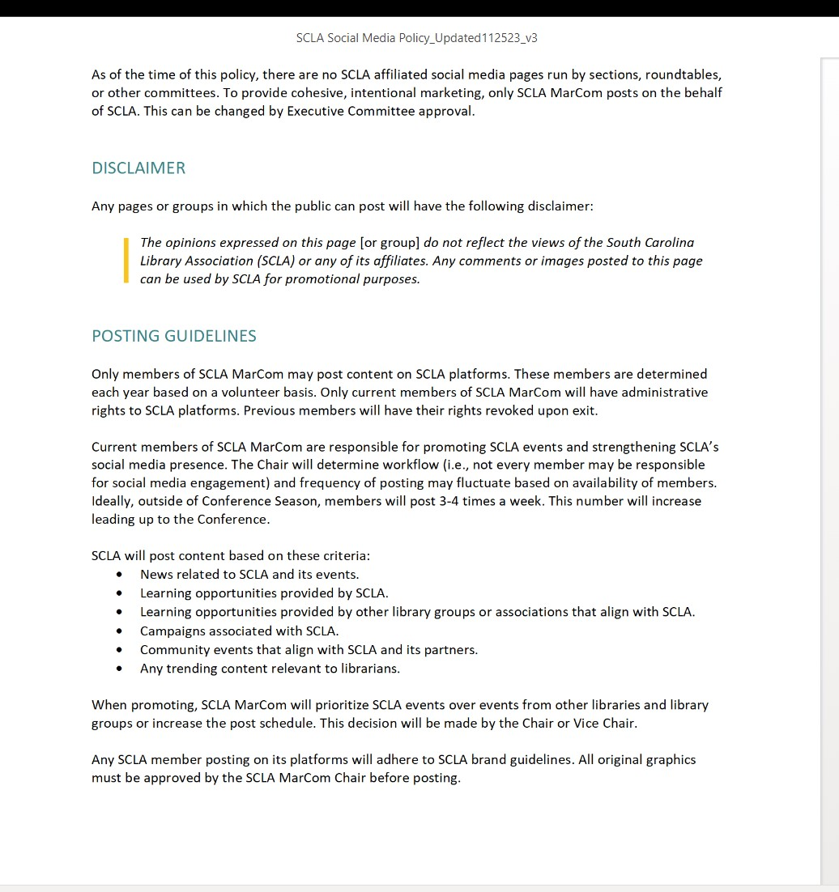
- The document starts with a mission statement of current platforms but is still investigating flicker. We decided to stay away from LinkedIn as everything we do on our website matches Linkedin. Also in the document is a list of current platforms.
- Members of the marketing committee discussed how to utilize our Facebook Page. Discovered there is an [unofficial] SCLA Facebook group. We need some moderators to generate the discussion in that group page.
- There are no SCLA-affiliated media pages that are run by sections or roundtables. To ensure cohesiveness, only the Marketing and Communication Committee posts on the social media pages on their behalf. But this can be changed with the approval of the executive committee. [ corrections if needed]

Motion to approve social media policy by SCLA Marketing
Motion- Kelly Jones
Second –Donald Wood
All in favor-

Committee, Roundtable, Section reports
Advocacy Committee- Jonathan Newton /Virgina Cononie
- Tomorrow, the Freedom to Read South Carolina Coalition has a call from 6-8pm. The first part of the call will be members from the pro truth coalition giving updates about the ongoing legislation, and the second part will be advocacy training provided by ACLU . [correction if needed]
- Legislation still out there- Transparency and Education Act, DEI Higher and Education Bill, and the Protection of Minors from Pornography and Obscenities Act, which removes exemptions from prosecution to librarians.
- See bill here: https://www.scstatehouse.gov/sess125_2023-2024/bills/3826.htm#:~:text=The%20following%20definitions%20apply%20to,degree%20sexual%20exploitation%20of%20a
- Building a strategic approach to contacting legislators and establishing relationships with them.
- April Cromer prefill a bill that called for allowing public library trustees to be removed by two-thirds votes from a county council.
- Link to bill : https://www.scstatehouse.gov/billsearch.php?billnumbers=4568&session=125&summary=B
- The State Board of Education proposes changes to regulations that give the state control over material selections in schools, and school libraries.

(Virgina Cononie reporting)
- Share your story theme, “Good News.” The due date is February 2024, and SCASL would like to have material created by Valentine Day for their visits.
- Reaching out to Pascal to support the material.

Management Section – Amanda Myers
- Host a panel discussion in September with library leaders across the state. We had 45 people signed into Zoom. The panel is recorded and featured on the SCLA website. We are planning to host another panel discussion in the spring.
- We have a slate of new officers – Vice Chair Tracy Elvis-Weitzel from Horry County Memorial Library and Secretary Kai Tang, Director of Library Experience from Richland County Library.
- Feedback in our survey for in person meet up opportunities. Also, we can collaborate with the new member roundtable and other sections or roundtables.

Marketing Committee – Sonaite Debebe- Kumssa
- I am the chair, Lindsey Taunton is the Vice Chair and Tomeka Jackson is the Secretary and will continue in those roles into 2024.
- If you need any assistance with marketing, mail us at web.scla@gmail.com. We highlight events, design graphics, and update information on committees, sections, or roundtables.
- Highlights- Posted 10 social media graphics to support the conference with [303] total interactions and we created the social media policy that was recently passed.
- All new officer updates will be on the SCLA website in January 2024.

Continuing Education Committee- Lisa Gieskes
- Successful conference with Valerie Byrd Font presenting her Get Ready Stay Ready Tool kit and Bryce Martin’s Zine program at Anderson County Public Library.
- We have new officers: Melanie Griffin at the South Carolina State Library, Amy Heimer at Charleston Public Library, and Leah Stapleton at Richland Library.
- Partnering with SCASL and offering continuing education opportunities.

College and University Section – Allison Read
- October – lunch and learn event on Trauma Informed Education.
- Sponsored two sections at the conference
- Full slate of officers for next year! We have a chair, vice chair, secretary, program coordinator
- Next week, we will have a meet and greet with new and past officers to discuss our plans for the new year.

Rainbow Roundtable- Kristin Hare
- Working on writing an article to submit to the South Carolina Journal about our panel at the conference.
- Working on looking over outdated and offensive language used in the SCLA handbook and reviewing our mission statement and goals.
- Questions raised at our last meeting on SCLA code of conduct generally for conferences, committees, or roundtables.
- Full slate of 2024 officers – Kristin Hare Chair, Michelle Rubino – Vice Chair, and Alex Biscoll as Secretary

New Members Roundtable- Randy Dantrell Heath
- Plan to connect with Amanda Myers and the Library Mangement Section for in person social ideas for the new member roundtable.
- Want to connect new member alumni with current members for mentorship opportunities.

Scholarship for Diversity in Librarianship Committee- Cathi Mack
- Present six scholarships to recipients at the conference.
- Raised $1,145 for the scholarship. Looking forward to fundraiser next year
- I would like to send out an e-blast for donations in June 2024, or it can be sent earlier to my email @ccoopermack@scsu.edu – please include your name, description, titles, and donation items.

Public Libraries Committee- Matthew Smith
- Business meeting at conference and hosted a section.
- We have new officers Kate Wiltrout as Vice Chair and Laura Sheely as secretary.
- Process of setting up discord server.

SELA Liaison- Doris Johnson-Felder
- Thank you for allowing me to serve as SELA representative for another year.

Tucky Taylor- Governance and Bylaws Committee
- Sonaite and Nathan flowers volunteered to be on the committee.
- We will continue reviewing the bylaws next year and then moving onto other documents.

New Business
- No new business

Board Retreat Date: TBA
Angela the new President will determine the next board retreat location and date.

Motion to go into Executive Session for contractual matter (current SCLA Board Members only)
Motion- Kelly Jones
Second- Tucky Taylor
All in favor

Executive Session-Contractual Matter
Motion to end Executive Session
Motion- Kelly Jones
Second- Tucky Taylor

Motion that board approves expenditures not to exceed 25,000 a year as discussed in Executive Session.
[ missed motions and second]
All in favor

12:00 Adjourn Meeting

