2017

CRISIS COMMUNICATION
TIPS & TRICKS
DEFINE

It’s an effort taken by a company to communicate with the public and stockholders when an unexpected event occurs that could have a negative impact on the company's reputation.

What incidents constitute as crisis communication:
- Severe weather
- Power outage
- Construction mishap
- Medical emergency
- Lockdown
- Accident
- Arrest

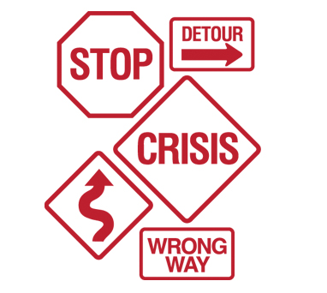

PREPARATION

What Community Relations Needs:
- Contact us ASAP
- Provide basic info
- Take in your surroundings
- Assume media will arrive
- Direct media to law enforcement or Community Relations Department
- Prepare for follow-ups from media and customers
- Be wary of what you say

What “Not” to Do:
- Don’t say, “no comment”
- Don’t fall for “off the record”
- Don’t guess or speculate
- Don’t drop names
- Don’t provide damage assessment
- Don’t try to cover up
- Don’t say media can’t speak with customers

What Media Are Looking For:
- Injuries/victims/casualties
- Property damage
- Causes
- Rescue and relief
- Description of crisis
- Legal action

Important Takeaways:
- No incident is too small to notify us about
- Rule of thumb… if emergency vehicles show up, probably a good idea to let us know
- It’s better to stay ahead of story than be blindsided
COMMUNITY RELATIONS DEPARTMENT

Contact Info:

Tamara King
- Community Relations Director
  - (p) 803-929-3466
  - (c) 803-457-0269
  - tking@richlandlibrary.com

Emily Stoll
- Community & Media Relations Coordinator
  - (p) 803-231-6388
  - (c) 803-587-3637
  - estoll@richlandlibrary.com

